E TICKETING SYTEM

USE CASE DIAGRAM

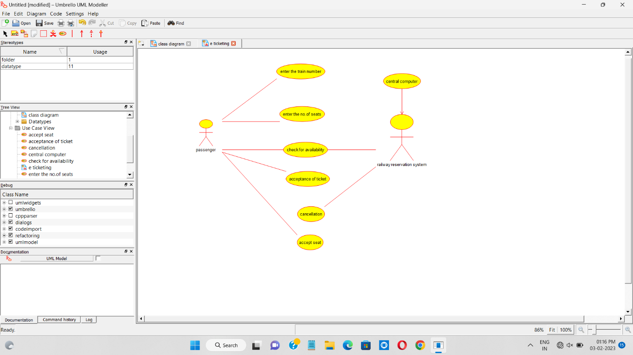

CLASS DIAGRAM

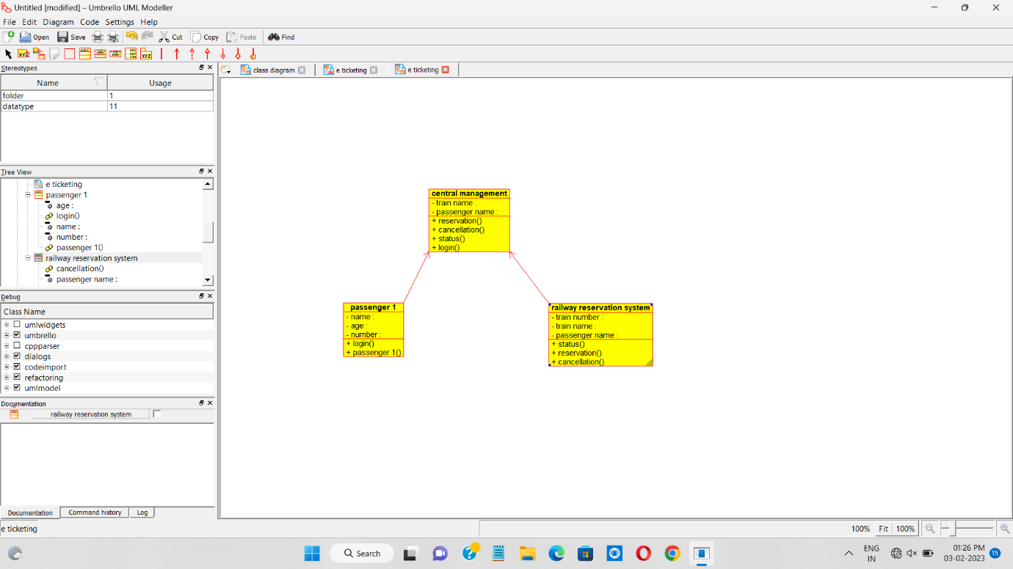

ACTVITY DIAGRAM

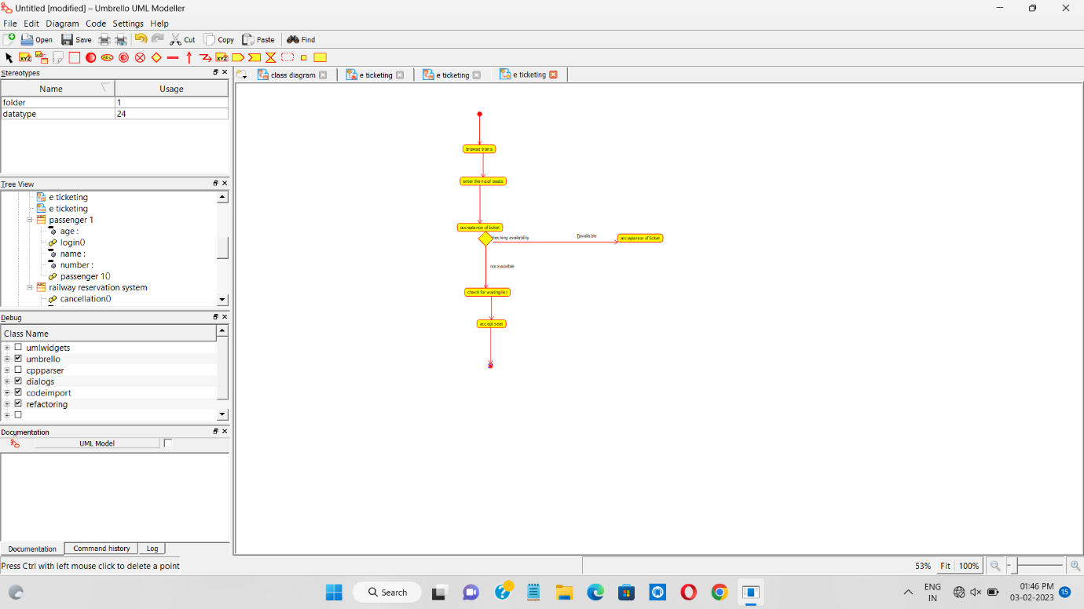

SEQUENCE DIAGRAM

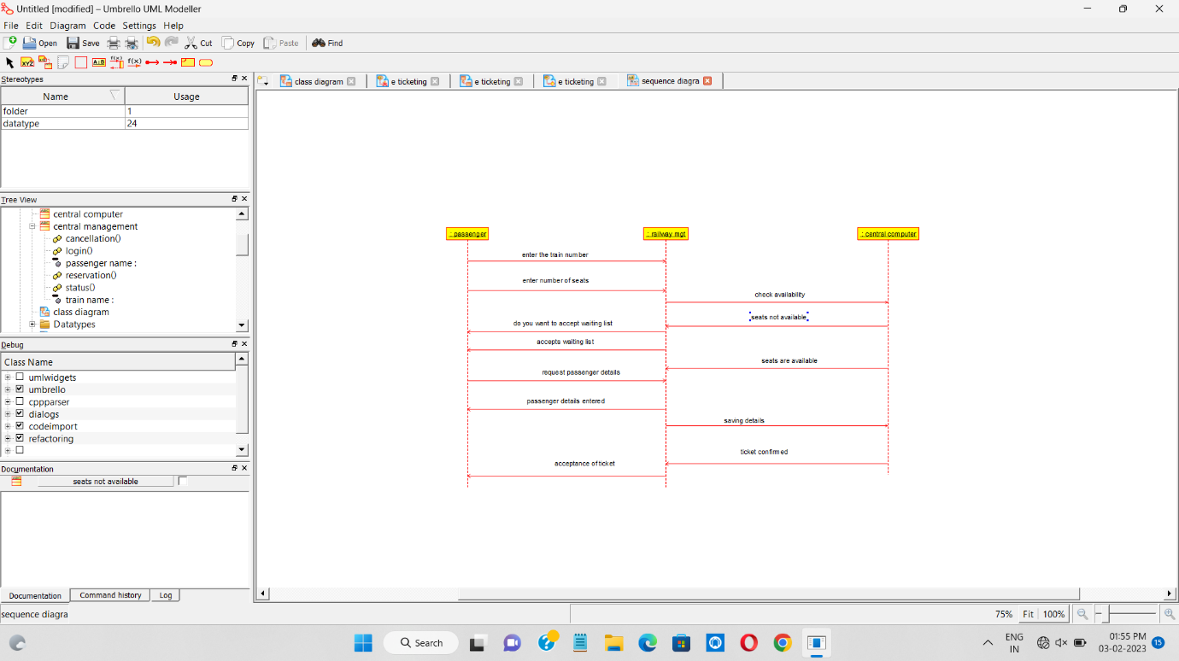

COLLABORATION DIAGRAM

